CSCN72010
Software Quality 1- Testing Tools and Methodologies

Assignment #2 (Part B)
Part B: System Testing using Selenium
Marks: 35
Dute: Oct/30/2023

For Assignment 2 (Part B), you will conduct system testing on the following website using Selenium Webdriver https://localhost/register/index.html

However, this website will be locally hosted on your computer using XAMPP ( Apache Server) Please read the following instructions carefully)

Steps to run the website from your local machine

Step 1: Download and install XAMPP from https://www.apachefriends.org/download.html

Step 2: Open the XAMPP control panel and start Apache and MySQL as shown below
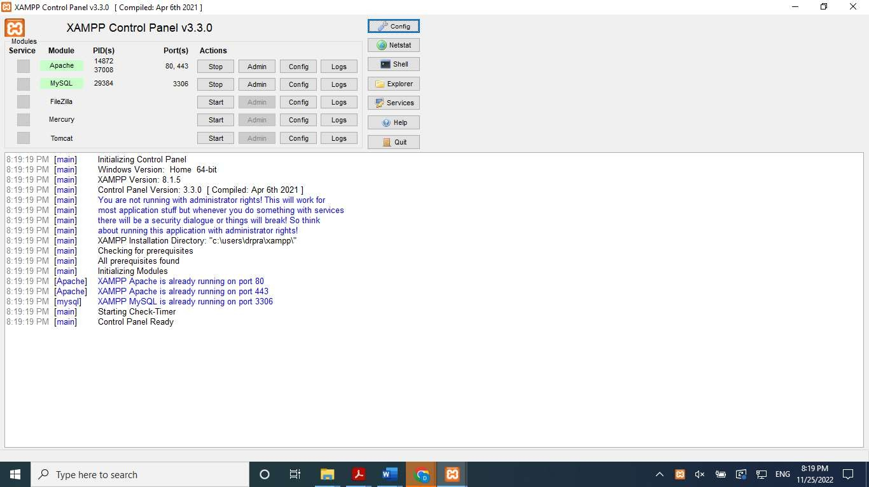

Step 3: A simple web application is available in eConestoga (Assignments\Register.zip). To use this web application, you will need to run the Apache server on your PC. You will need to copy register.zip into XAMPP\htdocs folder and then unzip it.

Click on the ‘Explorer” tab below to access XAMPP\htdocs

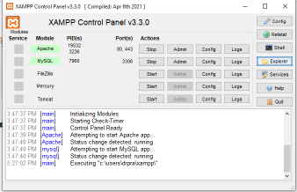

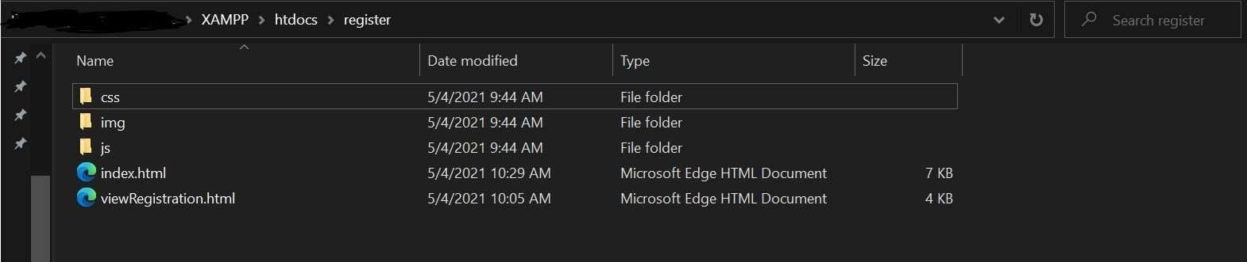
Open the following URL using Chrome (You will be using the Chrome browser for this assignment)
https://localhost/register/index.html

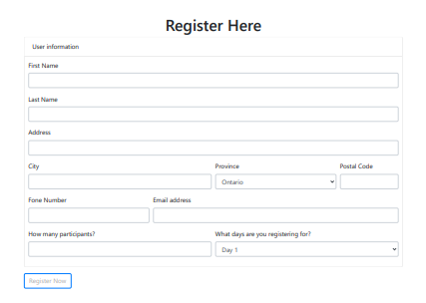

Upon entering relevant information and clicking on “Register Now “ , the following web page is seen

https://localhost/register/viewRegistration.html

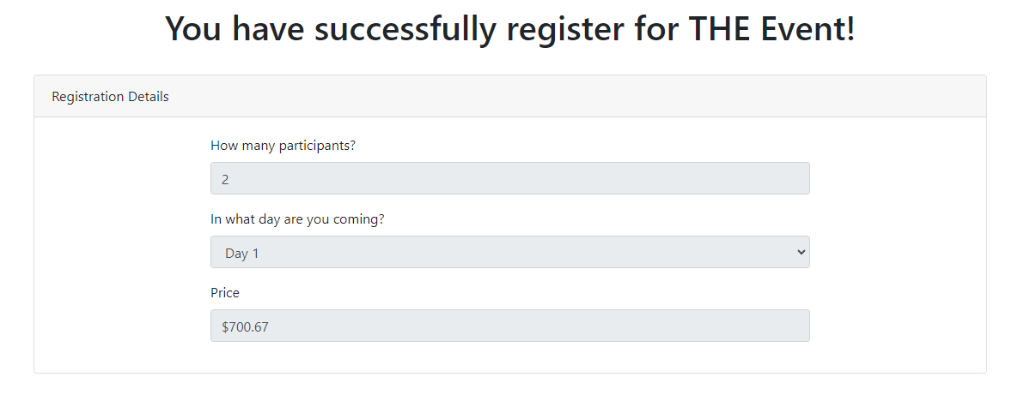

You are required to create system testing (test cases) using Selenium based on some of the following requirements.

Please Note: You will be creating 33 test cases (test methods) in total to do the following
- Demonstrate the working of the web application for valid data
- Uncover bugs (based on the requirements)

The Requirements for the web application are as follows:

- This web app allows users to register for an event called “THE Event!”
- Registrants must provide their first name, last name, address, city, province and postal code along with their phone number and email address.

- Registrants must also provide the number of participants attending and what day(s) they want to attend (either Day 1 or Day 2 or Both)
  - Registrants attending Day 1 will be charged $450
  - Registrants attending Day 2 will be charged $350
  - Registrants attending Day 1 and Day 2 will be charged $750 (as opposed to$800)
- Registrants registering more than five participants will be given a 10% discount

- Links are to be provided at the top of the web app to “THE Event!”, the home page, and to
the main page of Conestoga College.
- The list of provinces needs to contain all Canadian provinces and territories in an increasing alphabetized drop-down list
- The Phone Number field must only accept phone numbers of the form 111-111-1111 or (111)111-1111

- The Postal Code field must only accept in the format A1A 1A1 (where A represents an alpha character A-Z and 1 represents a digit from 0-9)
- Upon registering, a new page should show:
  - The number of participants
  - The days they are registered for
  - The total price (there is no tax or any other fees)
- Users should be able to go back to the main page after registering through alink.

Assignment Requirements: You are required to create 33 (thirty three) test cases using Selenium Webdriver for Chrome as follows:

- 12 test cases (with different input data) to show the working for each option selected in the menu option (Province)
In each of these test cases, you have to assert that upon entering valid data on https://localhost/register/index.html and clicking “Register Now”, the website https://localhost/register/viewRegistration.html is opened

- 6 test cases for “How many participants?” set to the following values.

  - 1,2,3,4,5 and 6
  - In each of these test cases, you have to assert that upon entering valid data on https://localhost/register/index.html and clicking “Register Now”, the website https://localhost/register/viewRegistration.html is opened
  - Any province can be selected

- Test cases to assert the following requirements
  - Registrants attending Day 1 will be charged $450 (3 test cases)
  - Registrants attending Day 2 will be charged $350 (3 test cases)
  - Registrants attending Day 1 and Day 2 will be charged $750 (as opposed to$800) (3 test case)
  - Registrants registering more than five participants will be given a 10% discount (3 test cases)
  - Links are to be provided and working at the top of the web app to “THE Event!”, the home page, and t the main page of Conestoga College on https://localhost/register/viewRegistration.html (One test case each for “The Event!” , home page and Conestoga College )

Submission Instructions:

  - Create an MSTEST (C#) project in Visual Studio (Name it SeleniumtestingA2)
    - Add Selenium and chrome related packages as explained in the class (lesson 5). The recording is available in case you need to review it.
  - Appropriate naming conventions must be used for all the 33 test methods
    - Arrange, Act and Assert must be clearly indicated
    - Other comments as deemed necessary can be included
  - Create a zip file of the solution (SeleniumtestingS2.zip) and uploa

